Magnonics 2025 abstract template – put here the title of your presentation
John Author¹, Lucy SecondAuthor^{2,3}
¹First affiliation
john.author@correspondence.email.com
²Second affiliation
³Third affiliation

This is an abstract template for the Magnonics 2025 Conference, which be held 28.07.25 - 1.08.25 in Cala Millor, Mallorca, Spain). Please keep your abstract to one page including figures, tables, references, acknowledgements, etc. The abstract should be written in English and may include figures and other objects as long as they fit within the one-page limit. Do not vary the margins or change the settings of this template (line spacing, font size, etc.).
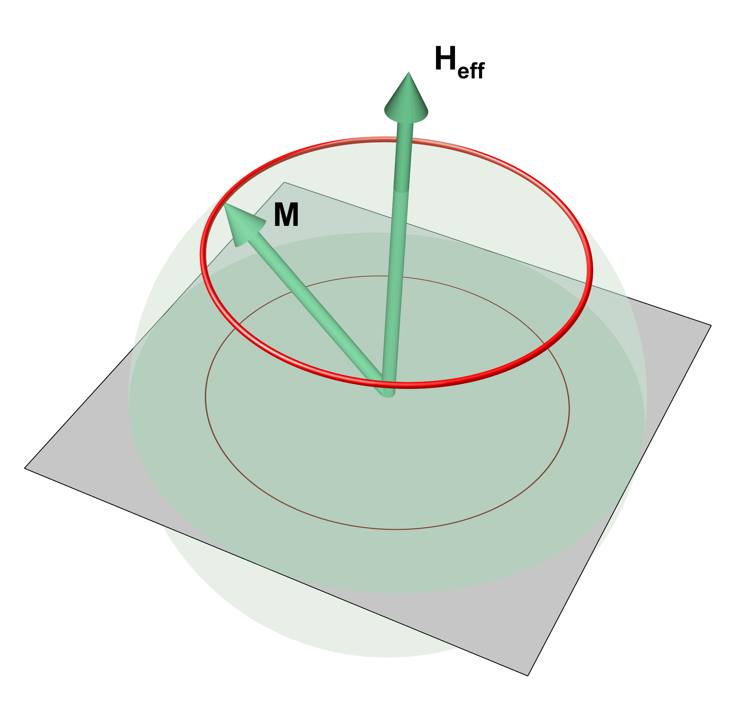
Figure 1. Example of figure and figure caption embedded in the main abstract text. Do not forget to cite the figure in the text of your abstract.
The figure caption should be placed below the figure (Fig. 1). It is recommended to position figures and captions using tables with transparent borders as suggested in this template.
Acknowledgements of funding may be placed after the main text of the abstract. If references are used, they should be numbered consecutively [1]. A suggested style for references is given at the end of the template [2].
The abstract should be submitted as a single MS Word file “AuthorName.docx” (file extension .docx only, not .doc!) via email to magnonics2025-abstract@uni-due.de. The size of the abstract should not exceed 10 Mb.
Please specify in your email the desired type of your contribution (talk/poster).
Please note that for security reasons, the emails with attachments in older Office file types (e.g. .doc) will not be accepted by the email server and will not reach the conference organizers.
You will receive an acknowledgement of the successful receipt of your abstract within 48 hours. If you do not receive such a confirmation, please contact the organizers.
The deadline for abstract submission is 17 February, 2025. Notification of acceptance is expected by 9 March, 2025.

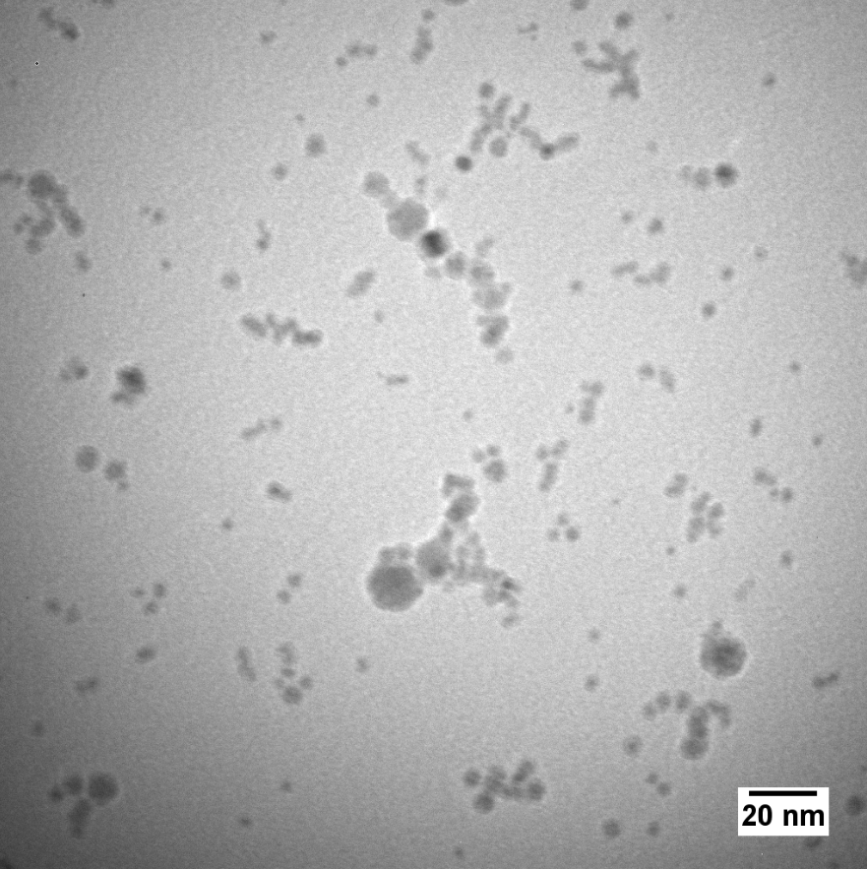
Figure 2. Example of figure and figure capture following the main abstract text. Do not forget to cite figure in the text of your abstract.

The financial funding from DFG (Project AA 1111/5-1) and IEEE is gratefully acknowledged.

[1] A.S. Clark et al., Materials Research Letters 12, 32 (2017)
[2] B. Liu et al., PRB 12, 247678 (2021)
[3] I.T. Prius et al., Sci. Rep. 3, 222 (2020)

